Change Order Request

July 8, 2016

Chinn Construction, LLC
14715 NE 95th Street, Suite 101
Redmond, WA 98052
Attn: Charlie Poggemann

Re: Hadley Apartment Project – Change Order Request – ASI-024R Shower Changes FINAL

Charlie,

One Way Plumbing total cost for work June 16 through June 29 for ASI-024R is $5,853 + 10% OH&P = $6,438.

Contingent upon no further work being requested due to ASI-024R, this will be the final COR for this issue. Please issue an official Change Order at your earliest convenience.

Let me know if you have any questions or comments. Thank you.

Sincerely,
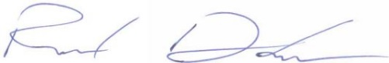
Richard Donelson
Project Manager / Estimator
LEED® Green Associate
richd@owpllc.net
425-591-4296 cell

